THE

CONTRACT

THE CONTACTS

PHONE & TEXT
Tara / General 952.237.6593

EMAIL
General info@taralatour.com
Tara tara@taralatour.com
Orders orders@taralatour.com
Media media@taralatour.com

SOCIAL MEDIA
Website https://www.taralatour.com
Instagram https://www.instagram.com/taralatour
Pinterest https://www.pinterest.com/taralatour

THE DEETS

ORDERING
Please email all purchase orders to Leah at orders@taralatour.com. An order confirmation will be sent for final approval. Please review to ensure accuracy in the order. All invoicing/shipping will also be communicated through Leah.

DELIVERY
All gowns are shipped via ground, unless otherwise noted or requested. Salons are responsible for cost of upgraded shipping if requested. Ship date listed on the order confirmation is an estimated date. The manufacturer will contact you if the estimated ship date changes.

Standard Delivery 12 weeks
Rush Delivery 8 weeks $150
Rush Delivery 4 weeks $300
Rush Delivery less than 4 weeks, please contact manufacturer.

SIZES
Sizes are chosen by the ordering party (bride/salon). All measurements should be taken by a bridal professional. Please refer to the Tara LaTour size chart to determine the appropriate size. Custom measurements are available for an additional fee. Tara LaTour is not responsible for ordered size, inaccurate measurements, and size changes in clients or for ordering in incorrect size.

PAYMENT
All payments are due prior to shipping, unless another arrangement is made with the manufacturer. All stock orders require a 50% deposit, unless otherwise specified or arrange with manufacturer.

REFUNDS
There are no refunds, changes or cancellation. No changes to the order may be made after the order is placed unless approved by the manufacturer. All Sales are Final.

ALTERATIONS
Tara LaTour is not responsible for any alterations needed and alterations are not included in the cost of the gown.

DYE LOTS
Dye lots can vary and we cannot be guaranteed by the manufacturer. For additional colors not listed, a color surcharge will be added. Also note that with natural fiber, flaws in the fabric can be naturally occurring and are part of the nature of the fabric.

PRICING & DISCOUNTING
We strongly advise all gowns to be at a set retail price of 2.2% from wholesale. Discounts are only allowed for special incentives, such as trunk shows.

CUSTOMIZE IT

ZIPPERS
Exposed Metal Zipper $30

NECKLINES
Necklines (and Backlines) are able to be raised or lower for an additional $75.

CUP ADJUSTMENTS
All gowns are made with a B-Cup. We can open up or subtract cups size for an additional $75.
(Please Note: Cup Adjustment and Neckline Raise in one order is $75 total).

TRAIN EXTENSIONS
Please see chart R+W CUSTOMIZATIONS SHEET.

EXTRA LENGTH
Please see chart R+W CUSTOMIZATIONS SHEET.

BUTTONS
We offer the addition of buttons on the back or front seams.
Covered Satin Buttons $6 per button. (Colors: Diamond White, Ivory, Cream, Ecru or Black)
Please indicate Buttons as add-on, with color, amount and placement directions.

COLORS
If a bride is looking for a custom color, please contact manufacturer. Additional fees may apply.

FRANKENSTEIN PRICING
Want to pair this skirt and that bodice. No problem! In order to streamline the process, we have created pre-determined (we call them “Frankenstein”) prices set for swapping skirts for each salon. Just find your folder in google drive, and you will find all the options and their prices.

MADE-TO-MEASURE / SPLIT-SIZING
We offer a made-to-measure option. A made-to-measure gown includes a complete custom pattern. This is a great option for someone that has a great variance from the size chart, as well as portions adjustment needs. This does not guarantee that the alterations will not be needed. Made-to-measure do not include custom hollow to hem.

-Bodice Shortening/Lengthening: $50
-Full Custom Pattern: $200. Included Bodice and Hips. Accounts for body length, width, and cup size.
-Custom Bodice Pattern $150. Included Bodice only. Accounts for body length, width, and cup size.
-Split Sizing is the same price as a custom pattern.

SIZE CHART

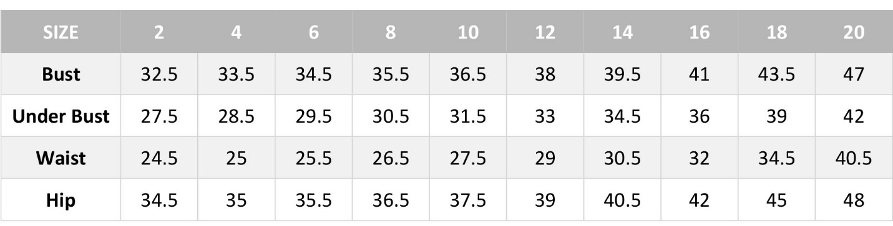

All size outside of the size chart, we will produce a custom bodice patterns for no additional charge

